Kyle Kirtland

<https://github.com/Redster11/CS_3700/tree/master/Project1>

1a) the file size is 43.7 KB (44,841 bytes)

1aa) average of .5ms

1ab) average of 10ms

1c) 300%

1d) the second method gives better compression however it takes 35ms which is a 1.3 speed up in time taken.

1e) no because it requires all the codes and to know how man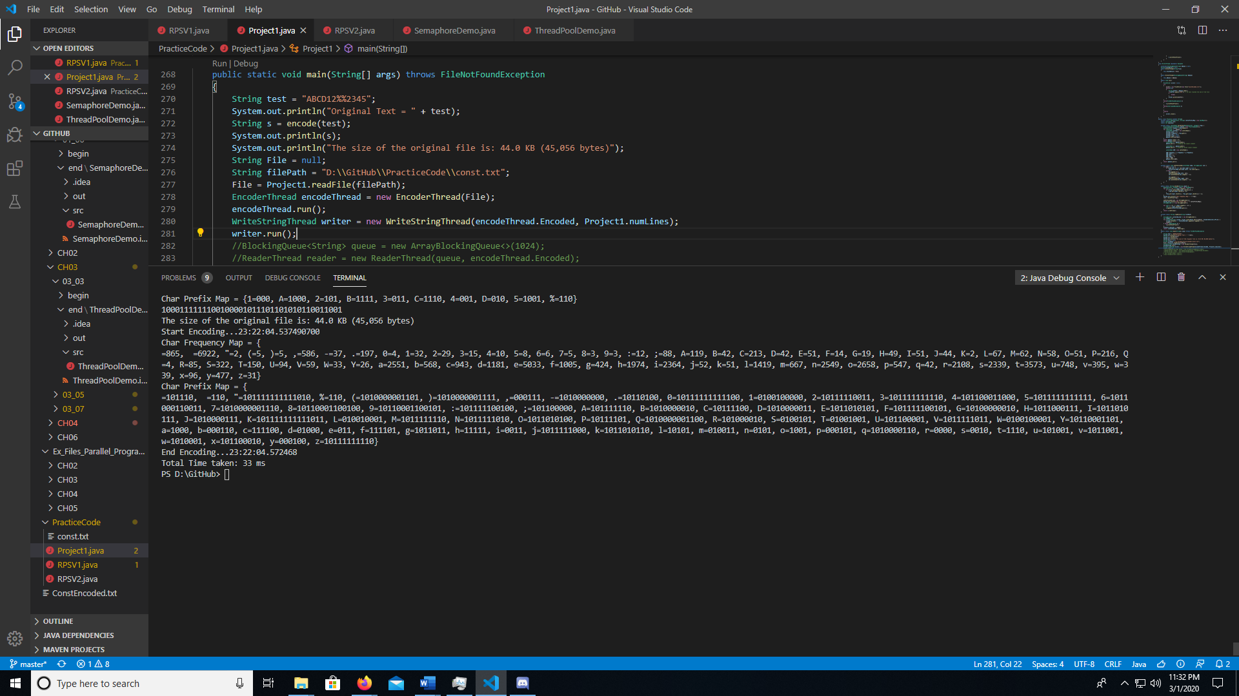y letters have been decoded so far

This is showing an output of the encoding for the entire file shows the Prefix Map and the Frequency Map.

It also shows a small test case.

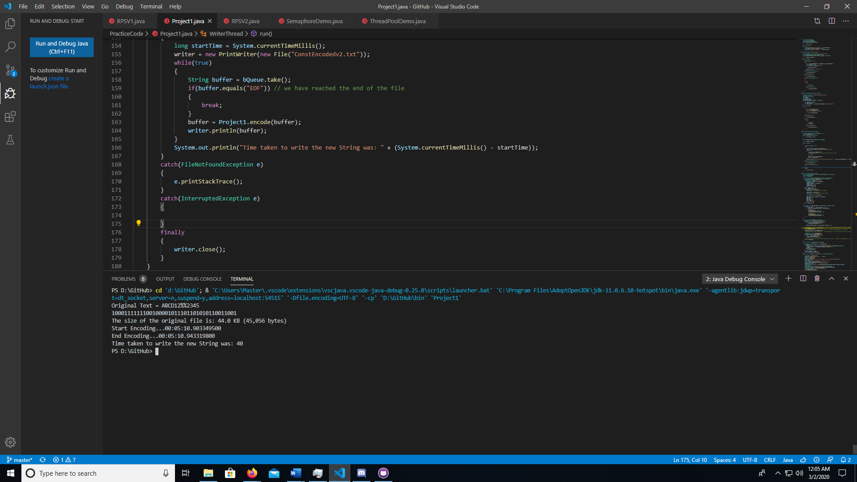

Showing this time of using a String as an input for saving feture

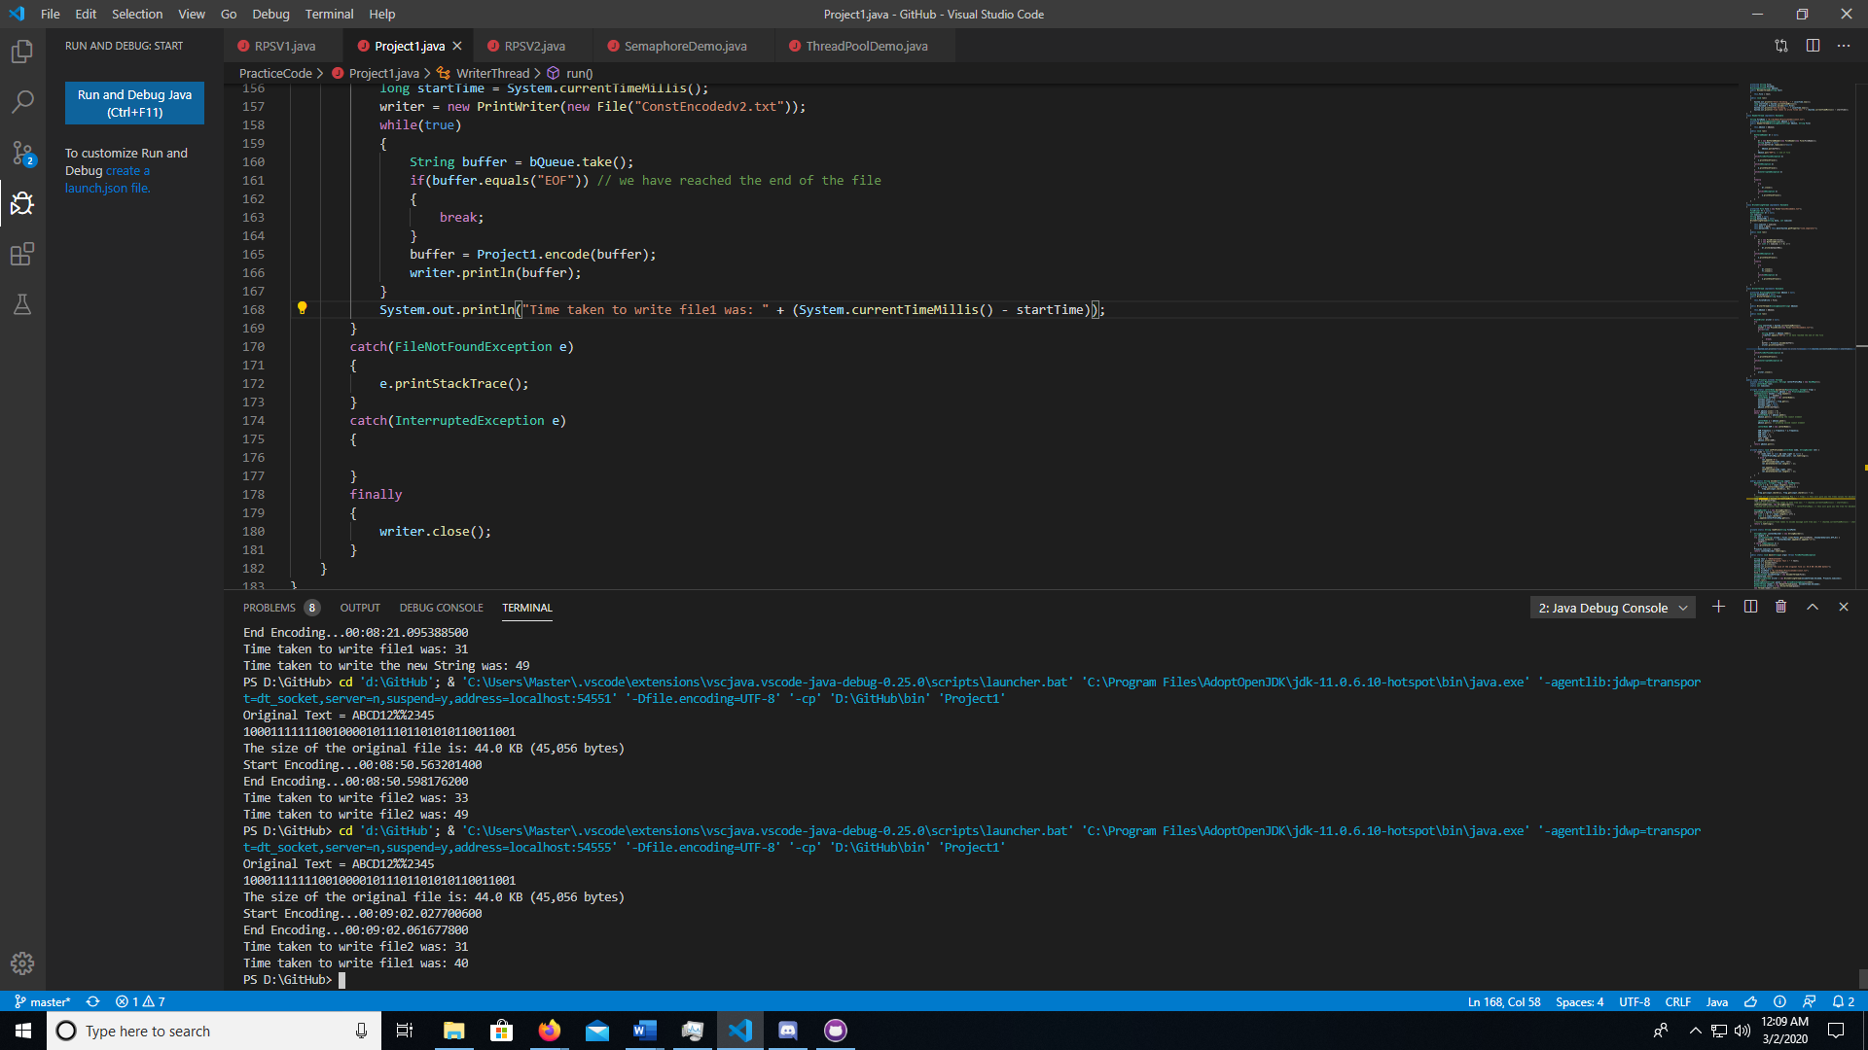

Showing time comparison between the buffer String and the String